H.T No
Regulations:
A18

Sreenidhi Institute of Science and Technology
(An Autonomous Institution)
Code No: 7A714 Date: 02-Jan-2025 (FN)

B.Tech IV-Year I- Semester External Examination, January-2025 (Supplementary)
POWER SYSTEM ANALYSIS AND CONTROL (EEE)

Time: 3 Hours Max.Marks:70

Note: a) No additional answer sheets will be provided.
b) All sub-parts of a question must be answered at one place only, otherwise it will not be valued.
c) Missing data can be assumed suitably.
Bloom's Cognitive Levels of Learning (BCLL)

Remember | L1 | Apply | L3 | Evaluate | L5
Understand | L2 | Analyze | L4 | Create | L6

Part - A Max.Marks:20

Answer all QUESTIONS.
 |  | BCLL | CO(s) | Marks
1 | What is an incidence, Matrix? Explain with a suitable example. | L1 | CO1 | [2M]
2 | Draw the block diagram of a isolated power system. | L3 | CO2 | [2M]
3 | Differentiate between single area and 2 area control | L4 | CO3 | [2M]
4 | Enumerate necessity of power flow studies. | L3 | CO4 | [2M]
5 | Write short notes on Steady state stability and transient stability. | L2 | CO5 | [2M]
6 | Draw the Heat curve and write short notes on it. | L6 | CO6 | [2M]
7 | Define slack bus? And what is the importance of it. | L3 | CO4 | [2M]
8 | How does PV bus influence the load flow solution? | L2 | CO4 | [2M]
9 | Give the advantages of optimal allocation of generators. | L2 | CO6 | [2M]
10 | Define synchronizing power coefficient. | L3 | CO5 | [2M]

Part – B Max.Marks:50
ANSWER ANY FIVE QUESTIONS. EACH QUESTION CARRIES 10 MARKS.

 |  |  | BCLL | CO(s) | Marks
11. | a) | Show that Y_{BUS} = A^{T} Ypre A. | L6 | CO1 | [5M]
 | b) | For the three-bus network shown in the following figure, build Z_{Bus}  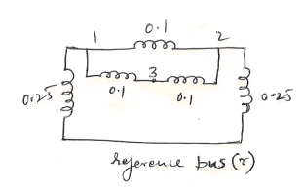 | L5 | CO1 | [5M]
12. | a) | Draw the transfer function of Speed governing system and deduce the necessary equations. | L4 | CO2 | [5M]
 | b) | Draw the schematic of excitation system model. | L4 | CO2 | [5M]
13. | a) | Derive necessary equations to determine load frequency control of two area machine for a uncontrolled case. | L3 | CO3 | [5M]
 | b) | Explain load frequency control and Economic dispatch control in a two area system . | L2 | CO3 | [5M]
14. | a) | Enumerate the features of Newton Raphson method for the convergence of load flow solution with a flow chart. | L6 | CO4 | [5M]
 | b) | Figure. shows a three bus power system. Bus 1 : Slack bus, V= 1.05/00 p.u. Bus 2 : PV bus, V = 1.0 p.u. Pg = 3 p.u. Bus 3 : PQ bus, PL = 4 p.u., QL = 2 p.u. Carry out one iteration of load flow solution by Gauss Seidel method.  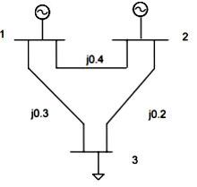 | L5 | CO4 | [5M]
15. | a) | Describe the methods to improve the stability | L1 | CO5 | [5M]
 | b) | Apply the knowledge of Equal area criterion with an example. | L3 | CO5 | [5M]
16. | a) | A Two bus system shown in figure. If 100MW is transmitted from plant 1 to load a transmission loss of 10MW is incurred. Find the required generation for each plant and the power received by the load when the system λ is Rs25/MWh  The Incremental fuel costs of the two plants are given below.  dC₁/dP_{G1}=0.02P_{G1}+16.00 Rs/MWh  dC₁/dP_{G2}=0.04P_{G2}+20.00 Rs/MWh  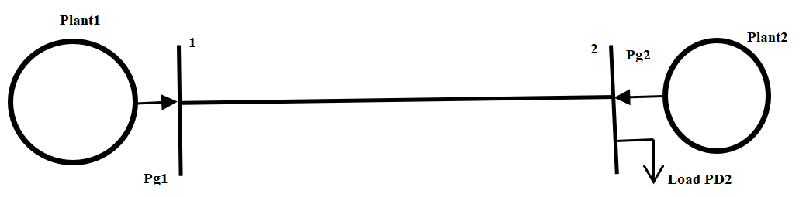 | L6 | CO6 | [5M]
 | b) | Write short notes on transmission line losses , Loss coefficients in a power system. | L2 | CO6 | [5M]
17. | a) | Explain ‘Equal Area Criterion’ of stability and clearly determine how you can find the stability limit of a synchronous motor when there is a sudden change in Mechanical power input to the machine. | L2 | CO1 | [4M]
 | b) | Derive the expression for finding out the critical clearing angle calculation | L3 | CO2 | [3M]
 | c) | Explain Z_{Bus} formation and Z_{Bus} building algorithm? | L1 | CO3 | [3M]
18. | a) | Briefly discuss about DC load flow method and its merits and demerits | L2 | CO4 | [4M]
 | b) | Why transient state stability limit is less than steady state stability limit? | L4 | CO5 | [3M]
 | c) | Elaborate on cost curve | L3 | CO6 | [3M]

-- 00 -- 00 –

